|  |  |  |  |
| --- | --- | --- | --- |
| Patient Name | **HARNAM SINGH** | Lab No | 04202105160003 |
| Age/Sex | 58 YRS/MALE | Reg Date | 17/JAN/2022 10:40 AM |
| Referred By | SELF | Sample Coll. Date | 17/JAN/2022 10:42 AM |
|  |  | Sample Rec. Date | 17/JAN/2022 10:50 AM |
| Ref. Lab/Hosp |  | Report Date | 17/JAN/2022 02:15 PM |
| SRF ID | 0767100821720 | Nationality | Select |
|  |  | Passport No |  |

**Test Name With Methodology Result Unit Biological Ref.Interval**

# MOLECULAR BIOLOGY

**COVID-19 (SARS-Cov-2) RT-PCR**

## Covid-19 RT PCR

Real Time PCR

## Negative

### Note: ICMR Registration number for COVID 19 is ADAHDPDD

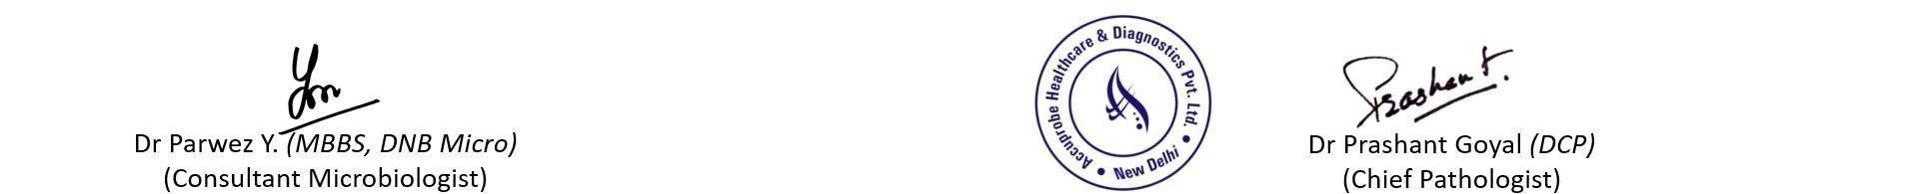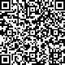

**Sample type: Nasopharyngeal & Oropharyngeal swabs**

### Interpretation:

|  |  |
| --- | --- |
| Negative | RNA specific to SARS-CoV-2 not detected |
| Positive | RNA specific to SARS-CoV-2 detected |
| Inconclusive | This could be due to low viral load in the sample. A retesting on a fres sample is recomended for confirmation. |

h

Negative result does not rule out the possibility of Covid 19 infection. Presence of inhibition, mutations and insufficient R NA specific to SARSCoV-2 can influence the test result.

Kindly correlate the results with clinical findings. Test is conducted as per kits approved by ICMR.

Kindly consult referring Physician/authorized hospitals for appropriate follow up.

### Disclaimer

1.This test is intended for use in conjunction with clinical presentation and other laboratory markers. 2.Improper specimen collection, handling, storage and transportation may results in false negative results. 3.The report represents only the specimen received in laboratory.

The tests marked with an * are not accredited by NABL.

*** End Of Report ***

Page 1 of 1